Shakespeare's Macbeth and King James's witch hunts
http://www.historyextra.com/article/culture/shakespeare-macbeth-king-james-witch-hunts
The witch hunts that swept across Europe between 1450 and 1750 are one of the most controversial and terrifying phenomena in history, resulting in the trial of around 100,000 people (most of them women), a little under half of whom were put to death. Here, Tracy Borman explores the most notorious royal witch-hunter of all time: James VI and I…
Monday 18th April 2016
Submitted by: Emma Mason
Share
Tweet
Plus
BBC History Magazine - 5 issues for £5
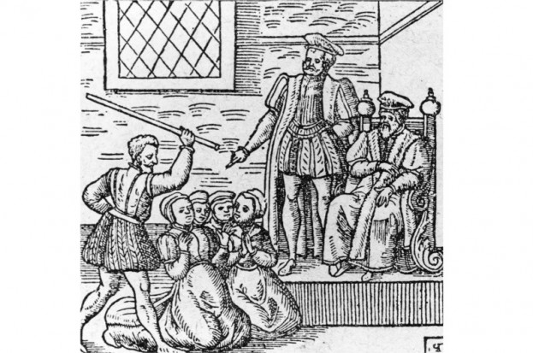
A holocaust of their time, historians have long attempted to explain why and how the European witch craze that spread around Europe between the 15th and 18th century took such rapid and enduring hold.
One of the most active centres of witch-hunting was Scotland, where up to 4,000 people were put to the flames. This was striking for such a small country, and was more than double the execution rate in England. The ferocity of the Scottish persecutions can be attributed to royal witch-hunter James VI (who became James I of England).
James’s obsession with witchcraft can be traced back to his childhood. The violent death of his mother, Mary, Queen of Scots, seems to have inspired a dark fascination with magic. “His Highness told me her death was visible in Scotland before it did really happen,” related Sir John Harington many years later, being, as he said, “spoken of in secret by those whose power of sight presented to them a bloody head dancing in the air”.
Two years after Mary’s execution, another dramatic event deepened James’s growing obsession with magic and witchcraft. In 1589 he was betrothed to Anne of Denmark, but she almost lost her life in a violent tempest when she set sail across the North Sea to meet her new husband. In an uncharacteristic show of chivalry, James resolved to sail across to Denmark and collect her in person. But on their return voyage the royal fleet was battered by more storms and one of the ships was lost. James immediately placed the blame on witches, claiming that they must have cast evil spells upon his fleet.
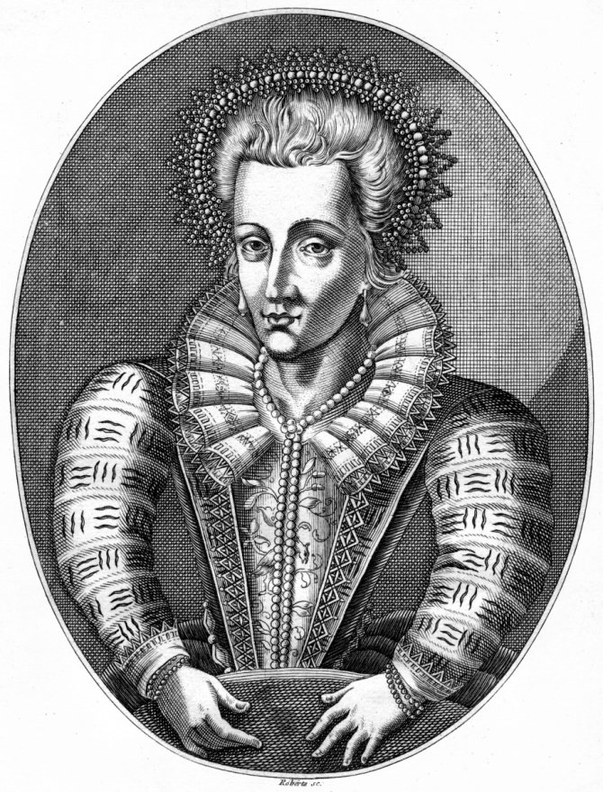
Anne of Denmark, queen consort of King James VI and I. (Photo by The Print Collector/Print Collector/Getty Images)
As soon as he reached Scottish shores, James ordered a witch-hunt on a scale never seen before. No fewer than 70 suspects were rounded up in the coastal Scottish town of North Berwick on suspicion of raising a storm to destroy James and his new bride. Most of the suspects soon confessed – under torture – to concocting a host of bizarre and gruesome spells and rituals in order to whip up the storm. They included binding the severed genitalia and limbs of a dead man to the legs of a cat and then tossing it into the waves, whereupon “there did arise such a tempest in the sea, as a greater hath not been seen”. On another occasion, Satan himself was said to have appeared to the witches and “promised to raise a mist, and cast the king into England, for which purpose he threw into the sea a thing like a foot-ball”. They were swiftly convicted and put to death.
As soon as the North Berwick trials had ended, James commissioned Newes from Scotland, a pamphlet that relayed the whole saga in scandalised language aimed at intensifying popular fear of witches. But he did not stop there. With all the passion of a religious zealot, James set about convincing his subjects of the evil that lay in their midst. In 1597 James became the only monarch in history to publish a treatise on witchcraft: Daemonologie (literally, ‘the science of demons’) was the result of painstaking and meticulous work on James’s part and must have taken years to complete. As well as to convince the doubters of the existence of witchcraft, the purpose of Daemonologie was to inspire those who persecuted witches with new vigour and determination. James described witchcraft as “high treason against God”, which meant that all manner of horrors were justified in wringing confessions from the accused.
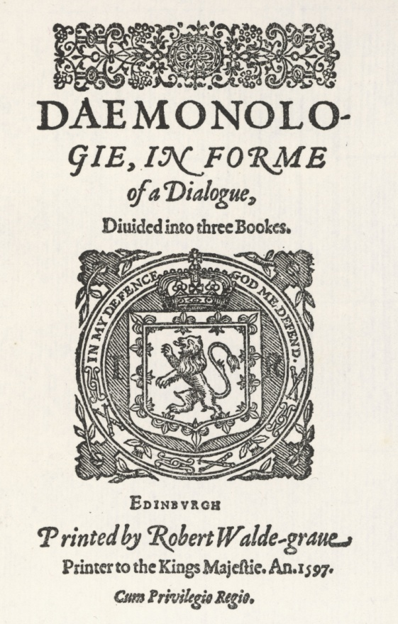
King James VI and I's treatise on witchcraft, 'Daemonologie', published in 1597. (© Mary Evans Picture Library/Alamy Stock Photo)
The fact that the treatise had been written by a king made it enormously influential. It is no coincidence that cases of witchcraft multiplied at an alarming rate in his kingdom thereafter.
Upon the death of Elizabeth I in March 1603 with no direct heirs, her throne passed to James. When he travelled south to take ownership of his new kingdom, the king of Scots was dismayed to find that his English subjects were far from sharing his witch-hunting fervour. By the end of Elizabeth’s reign, the number of witchcraft trials and executions in England had declined significantly. There was also a growing scepticism about the existence of witches.
This was anathema to the new king, who was determined to drown out all dissenting voices within his new kingdom. During the first year of his reign, Daemonologie was reprinted twice. This prompted a rash of similar pamphlets aimed at whipping up popular fear of witches. As part of a state-controlled printing industry, they became one of the most valuable means by which James and his government could manipulate public opinion.
But these publications were just the tip of the iceberg as far as James’s crusade against witches was concerned. In his view, the English law was by no means strict enough in prosecuting the crime. Barely a year after his accession, James therefore ordered that the Elizabethan statute on witchcraft be replaced by a much harsher version. Until now, those who practised witchcraft were severely punished only if they were found to have committed murder or other injuries through their devilish arts. However, James wanted the practice of any form of magic to be severely punished, regardless of whether it had caused harm to others.
The Witchcraft Act of 1604 made hanging mandatory for a first offence of witchcraft, even if the accused had not committed murder. And if the suspected witch was found to have the devil’s mark on their body, this was enough to condemn them to death. The act stipulated: “If any person or persons... shall use practise or exercise any invocation or conjuration of any evil or wicked spirit, or shall consult, covenant with, entertain, employ, feed, or reward any evil and wicked spirit to or for any intent or purpose... [they] shall suffer pains of death”.
James’s determination to stamp out witchcraft in all forms was brutally apparent: “All manner of practise, use or exercise of witchcraft, enchantment, charm or sorcery should be from henceforth utterly avoided, abolished, and taken away.”
James’s new subjects were eager to curry favour with him by echoing his hatred of witches. In the same year that the new Witchcraft Act was passed, Christopher Marlowe’s dark morality play, The Tragicall History of the Life and Death of Doctor Faustus, was published. This had first been performed in around 1588, five years before the playwright’s death, and was one of the most shocking portrayals of witchcraft ever to be performed. Audiences were so aghast at the horrors that unfolded before them on stage that some claimed to have been driven mad by it, and on occasion real devils were said to have appeared on stage, “to the great amazement of both the actors and spectators”.
As well as terrifying people into avoiding any dabbling with necromancy, the play also intensified their hatred and fear of witches. It can have been no coincidence that it was published in the very year that James I began his crusade against witchcraft in England.
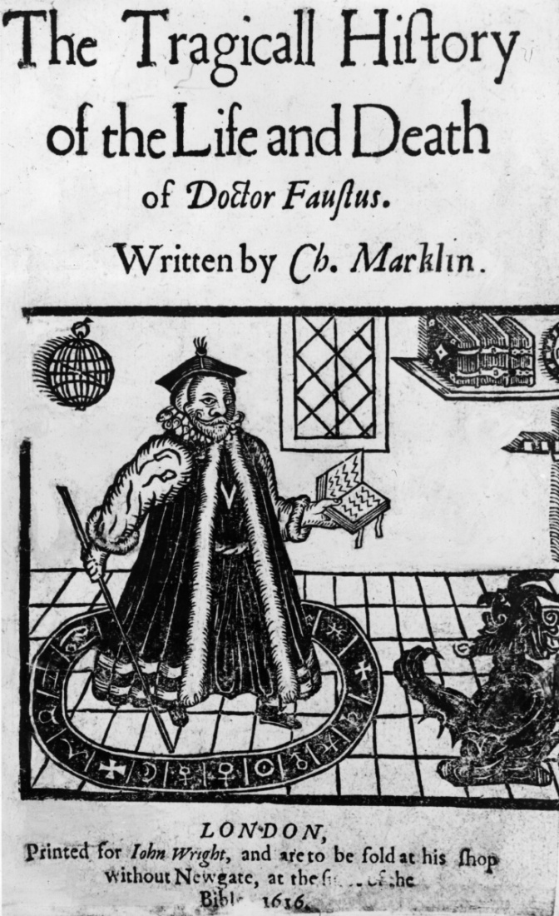
An illustration of the 1616 cover to 'The Tragicall History of the Life and Death of Doctor Faustus’. Christopher Marlowe's first edition was printed in 1604. (Photo by Hulton Archive/Getty Images)
Other playwrights were quick to follow suit. Ben Jonson devised a number of masques for the entertainment of the king and his court. The ‘antimasque’ to his Masque of Queens included the presentation of a group of witches who represented “the opposites to good fame”.
The playwright had clearly done a great deal of research, for he referenced a range of current and classical demonological works as his sources. He set out detailed instructions for the staging of the antimasque, describing the entering on stage of 11 witches “some with rats on their head; some on their shoulders; others with ointment pots at their girdles; all… making a confused noise, with strange gestures”. One of their number was “naked armed, bare-footed, her frock tucked, her hair knotted, and folded with vipers; in her hand a torch made of a dead man’s arm, lighted; girded with a snake”.
But the most famous of all the literary works inspired by witchcraft, winning widespread acclaim in its day and ever since, was Shakespeare’s Macbeth. Deliberately short in length (James was known to have little patience for sitting through long plays), it is significant that the occasion of its inaugural performance was a visit by Queen Anne’s brother, the king of Denmark, in 1606, given that it was James’s voyage to his wife’s native land that had prompted his obsession with witchcraft.
Shakespeare wove in several references to this voyage in the play, such as when the First Witch claims that she set sail in a sieve, just as one of the North Berwick witches was accused of doing. The line “Though his bark cannot be lost/Yet it shall be tempest-tossed” almost certainly alluded to James’s near-death experience in 1589.
Macbeth and the Three Witches, from 'Chronicles of England, Scotlande, and Irelande' by Raphael Holinshed, 1577. (Photo by Culture Club/Getty Images)
All the leaders of the English judiciary would have been present at this important state occasion, and this was exactly the sort of play that would inspire within them the same witch-hunting fervour as their royal master. The drama centred around Macbeth and Lady Macbeth, who murdered King Duncan to seize the throne of Scotland after three witches prophesied Macbeth’s succession.
Whether the witches thus caused the overthrow of the natural succession or merely brought out Macbeth’s inherent evil was left to the audience’s imagination. Either way, the play both confirmed and introduced new elements to the stereotypical view of a witch, with her spells, familiars and inherent evil. It also spawned two of the most-quoted lines in English literary history:
“Double, double, toil and trouble;
Fire burn, and cauldron bubble.”
Macbeth instilled fear among those watching that witchcraft was not just a satanic confederacy, but a conspiracy against the state. The latter notion was all too readily accepted in England at this time because the play was performed just a few months after one of the most notorious conspiracies in history: the gunpowder plot.
Within the space of three short years, England had been catapulted from the ‘golden age’ of the Virgin Queen into one of the darkest and most dangerous periods of its history.
Tracy Borman is author of Witches: James I and the English Witch Hunts (Vintage, 2014). To find out more about Tracy, visit www.tracyborman.co.uk.

http://www.historyextra.com/article/culture/shakespeare-macbeth-king-james-witch-hunts

