1597: James VI of Scotland writes Daemonologie, a book on witchcraft.
1603 Elizabeth I died; James VI of Scotland becomes James I of England
1605, King James 9/11: the Gunpowder Treason Plot or the Jesuit Treason, was an alleged assassination attempt against King James I of England and VI of Scotland by a group of provincial English Catholics led by Robert Catesby.
On August 7, 1606 What was the occasion for the first performance of Macbeth? A visit by the king of Denmark, to his sister, Queen Anne? Note that it was James’s voyage to his wife’s native land that had allegedly prompted his obsession with witchcraft.
1608 English dissenters had to find refuge in the Netherlands which momentarily tolerated various stripes of Protestantism; James I persecuted anyone who resisted the Church of England of which he was pope; woe unto you if you were charged with witchcraft;
1611 Written in 1609/10, Cymbeline was first performed in 1611 for then ruling King James; however, the play was not published until 1623, as part of the First Folio.
1611 Shakespeare forced off the stage
1613 Shakespeare attempts a comeback with Henry VIII, but the theater burned down during the first performance.
===========
Between 1590 and 1662, five intense witchhunt panics erupted across Scotland: 1590-91, 1597, 1628-1631, 1649-1650, and 1661-62.
As a result of these panics, out of a population of roughly a million people, about 2,500 accused witches, most of them women, were executed – five times the average European execution rate per capita. Scotland’s susceptibility to widespread panic over witches and witchcraft was, in part, determined by the role of one man: the Scottish ruler King James VI, who, following the death of Elizabeth I, became King James I of England in 1603.
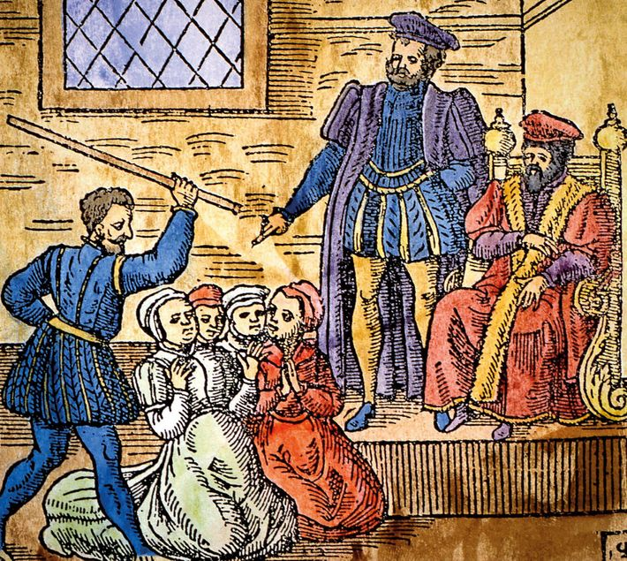
King James VI of Scotland (seated, right) supervising the torture of witches in Edinburgh, detail of a woodcut from the 1591 pamphlet Newes From Scotland.
=================================
A little background on James VI of Scotland, who assumed the throne of England in 1603 as James I.
Cymbeline was written sometime before 1611; Shakespeare was not played on stage after 1610 until he attempted a comeback in 1613, but the theater burned down during the first performance.
http://www.historyextra.com/article/culture/shakespeare-macbeth-king-james-witch-hunts
====================================================================================
One of the most active centres of witch-hunting was Scotland, where up to 4,000 people were put to the flames. This was striking for such a small country, and was more than double the execution rate in England. The ferocity of the Scottish persecutions can be attributed to royal witch-hunter James VI and I.
James’s obsession with witchcraft can be traced back to his childhood. The violent death of his mother, Mary, Queen of Scots, seems to have inspired a dark fascination with magic. “His Highness told me her death was visible in Scotland before it did really happen,” related Sir John Harington many years later, being, as he said, “spoken of in secret by those whose power of sight presented to them a bloody head dancing in the air”.
Two years after Mary’s execution, another dramatic event deepened James’s growing obsession with magic and witchcraft. In 1589 he was betrothed to Anne of Denmark, but she almost lost her life in a violent tempest when she set sail across the North Sea to meet her new husband. In an uncharacteristic show of chivalry, James resolved to sail across to Denmark and collect her in person. But on their return voyage the royal fleet was battered by more storms and one of the ships was lost. James immediately placed the blame on witches, claiming that they must have cast evil spells upon his fleet.
As soon as he reached Scottish shores, James ordered a witch-hunt on a scale never seen before. No fewer than 70 suspects were rounded up in the coastal Scottish town of North Berwick on suspicion of raising a storm to destroy James and his new bride. Most of the suspects soon confessed – under torture – to concocting a host of bizarre and gruesome spells and rituals in order to whip up the storm. They included binding the severed genitalia and limbs of a dead man to the legs of a cat and then tossing it into the waves, whereupon “there did arise such a tempest in the sea, as a greater hath not been seen”. On another occasion, Satan himself was said to have appeared to the witches and “promised to raise a mist, and cast the king into England, for which purpose he threw into the sea a thing like a foot-ball”. They were swiftly convicted and put to death.

